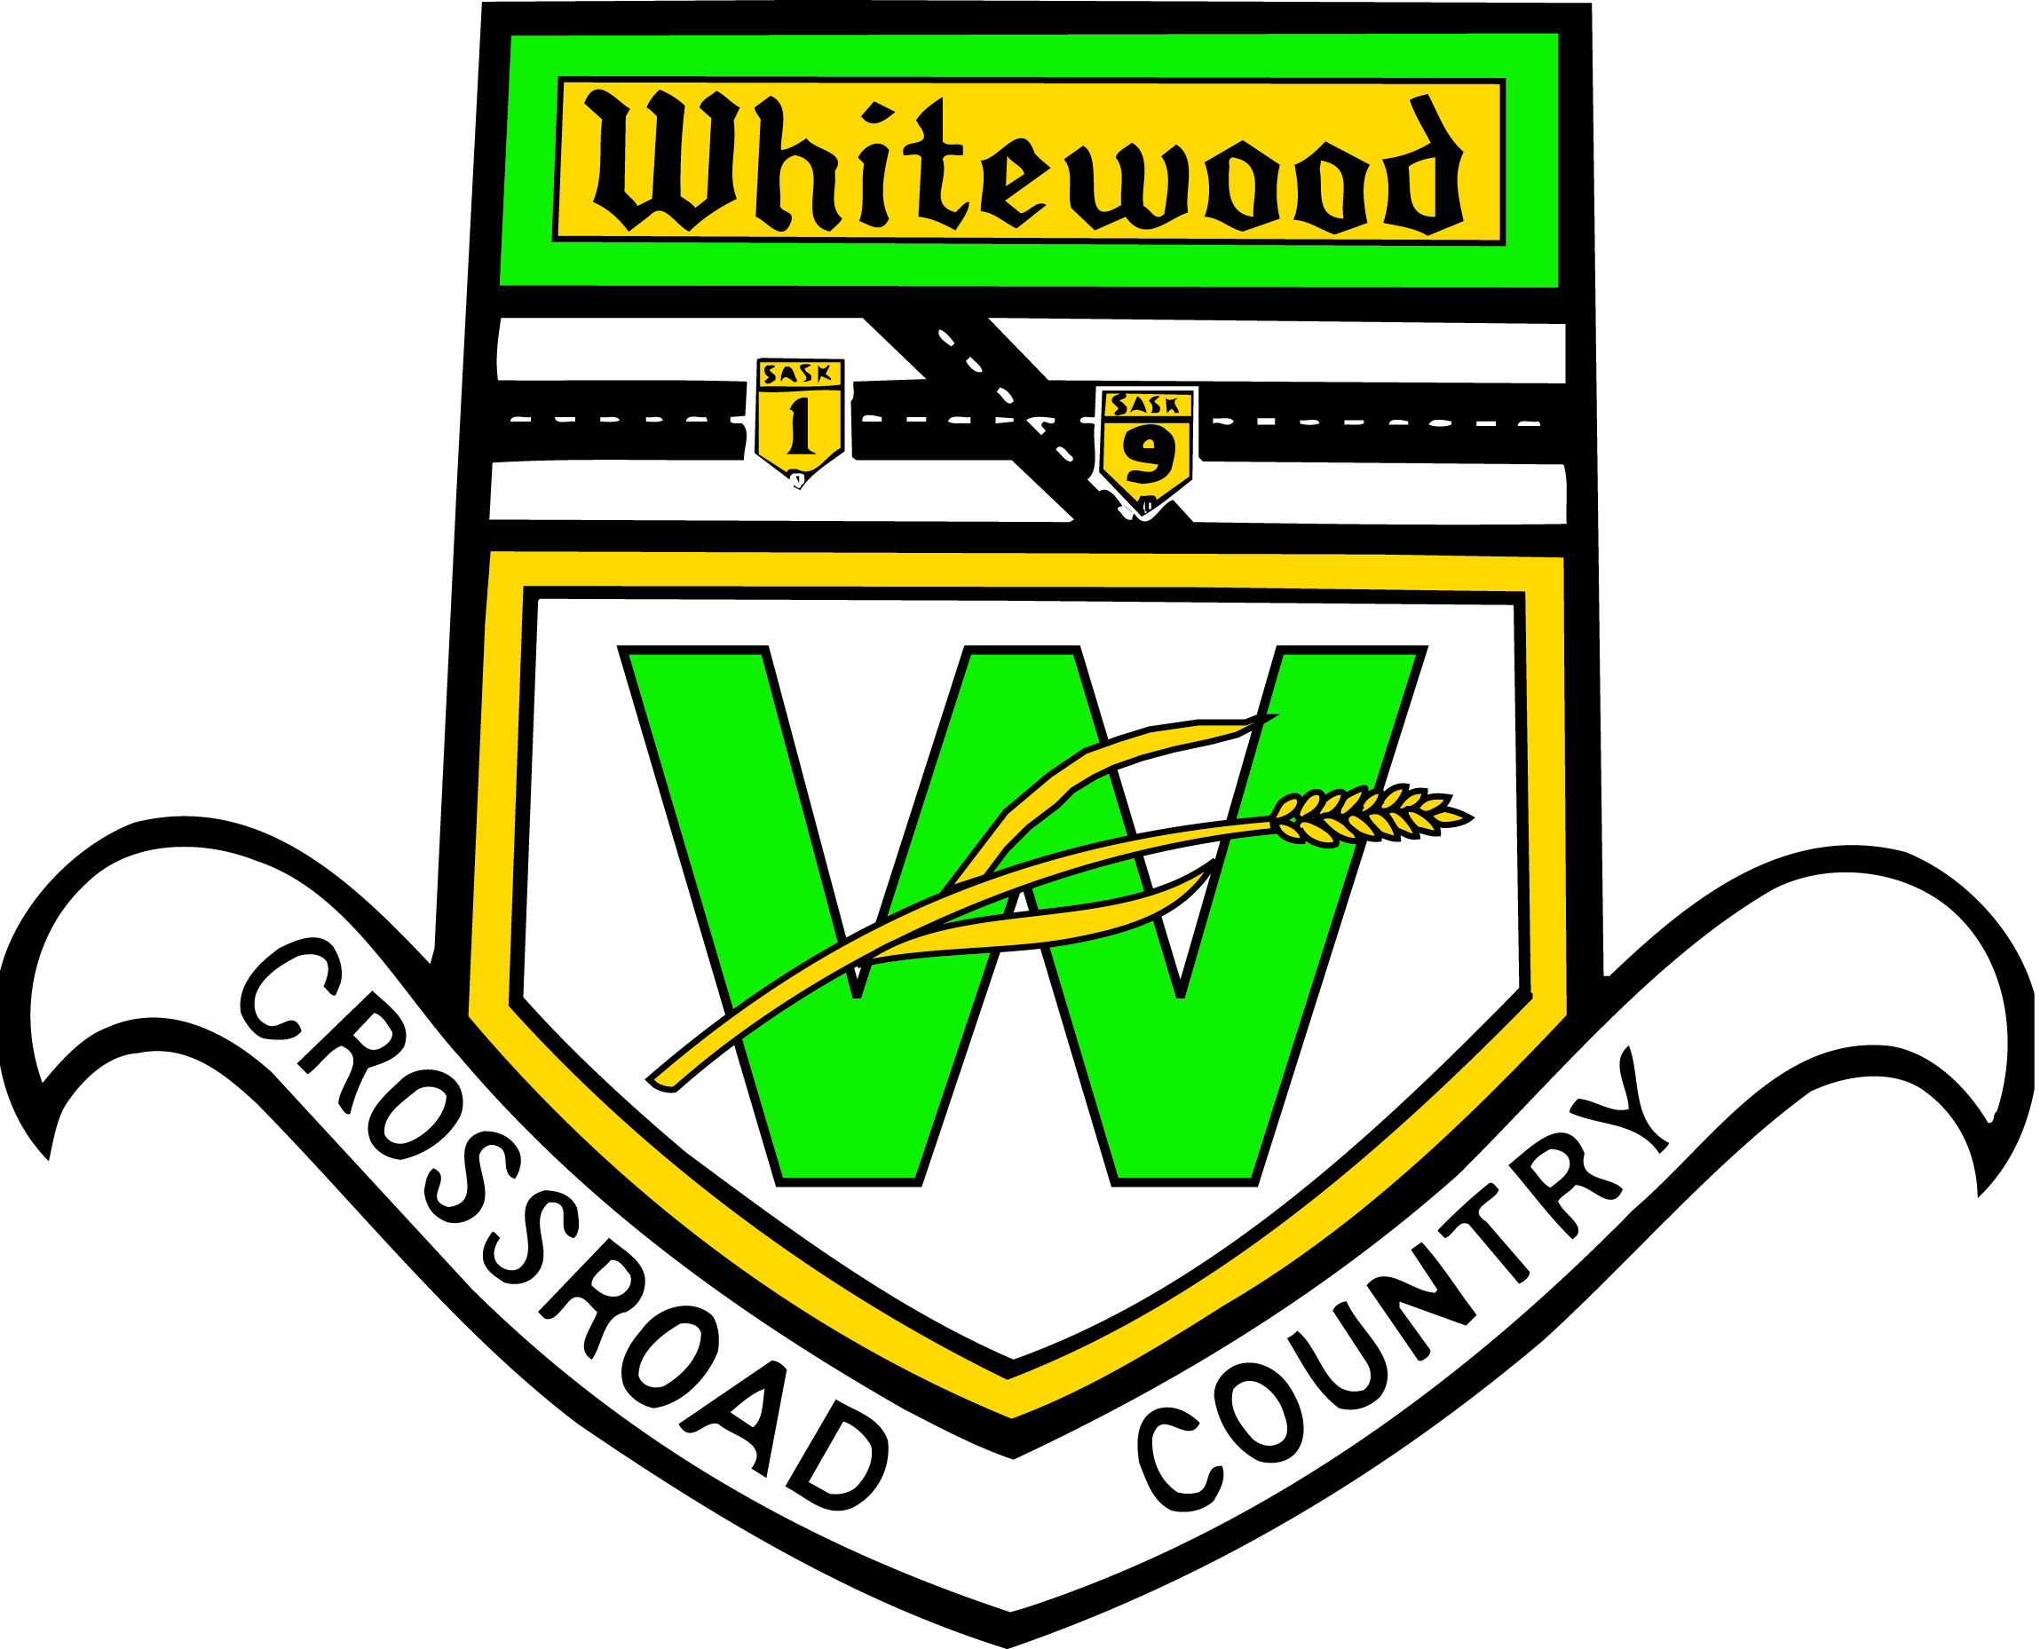
TOWN OF WHITEWOOD

REGULAR MEETING NOVEMBER 30, 2021

1. Call to order

1.1 Mayor Parks called the meeting to order at 7:00 p.m.

2. Approval of agenda

2.1 Adoption of Agenda

3. Adoption of minutes
3.1 November 16, 2021 Meeting Minutes

4. Delegate

5. Public Works Reports/Facility Operations Manager
5.1 WTP Operator report - 1st meeting of month
5.2 Foreman’s report - 1st meeting of month
5.3 Recreation Director’s report – PowerPoint Presentation
5.4 Operations Coordinator’s report – 2nd meeting of month

6. Reports
6.1 CAO report
6.2 Council Reports

7. Accounts
7.1 List of Accounts for Approval

8. Old Business
8.1 Folding Machine
8.2 Policy; Tax Exempt
8.3 Santa Day

9. New Business
9.1 Christmas Staff; supper? Gift?
9.2 Renewal with Balan Real Estate
9.3 Heritage Crescent Policy
9.4 ICIP Grant
9.5 Grasslands; Impaired Driving Ad
9.6 Grasslands; Christmas Ad
9.7 Suma via zoom; renewal rates
9.8 Town Apparel

9.9 Munisoft Training; year end & audit preparation
9.10 Meeting at school
9.11 UMAAS Workshop
9.12 Municipal Revenue Sharing Grant – Declaration of Eligibility

10. Closed Session of Council
10.1 Motion to go In Camera – Discuss regarding Personnel, legal matters and negotiations which are exempt from public discussion
10.2 Motion to come out of In Camera
10.3 Motions resulting from In Camera

11. Adjournment

