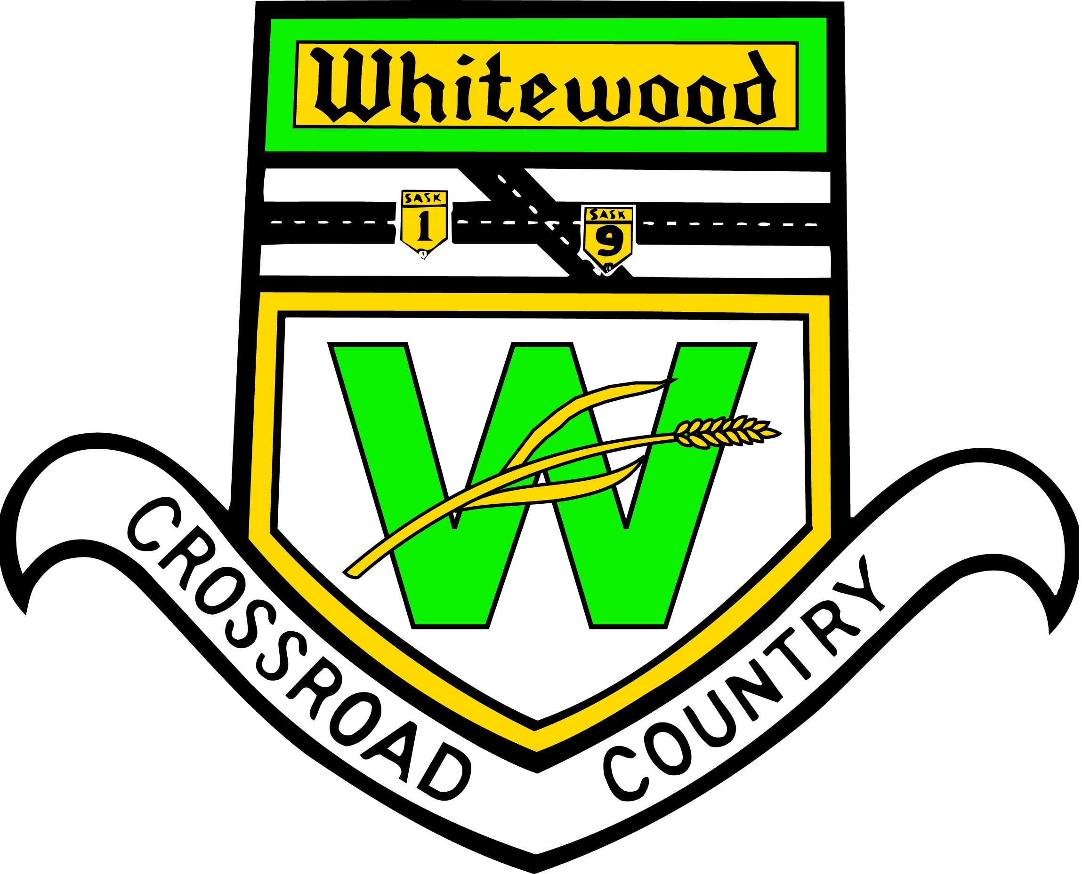
TOWN OF WHITEWOOD

REGULAR MEETING OCTOBER 7, 2025

- Call to order

2. Approval of agenda

2.1 Adoption of Agenda

Any agenda items listed or added, require any council to declare conflict of interest

3. Adoption of minutes
3.1 September 23, 2025 – Regular Council Meeting Minutes

4. Delegate –
As per request form signed Delegate only speaks on matter on form and maximum of 20 minutes, Council will then discuss matter

5. Public Works Reports/Facility Operations Manager
5.1 WTP Operator report – 1st meeting of month
5.2 Foreman’s report – 1st meeting of month
5.3 FOM’s report – 2nd meeting of month

6. Reports
6.1 CAO report
6.2 Council Reports

7. Accounts
7.1 List of Accounts for Approval
7.2 September 2025 PreAuthorized

8. Correspondence
8.1 Red Coast Waste Authority Minutes
8.2 Conexus Lagoon Loan
8.3 Letter of Support: Ponchos
8.4 SUMAinvest – Investment Policy & Agreement
8.5 Recreation Park
8.6 Southeast Regional Library

9. Old Business
9.1 Personnel Policy – adjust Stat holiday
9.2 CCBF (gas tax)

10. New Business
10.1 Borderland Coop – Outdoor arena sponsorship

11. Closed Session of Council – Discuss regarding Personnel, legal matters and negotiations which are exempt from public discussion
11.1 Motion to go In Camera
11.2 Motion to come out of In Camera
11.3 Motions resulting from In Camera

12. Adjournment

